
Liquid Rocket Engine Test Stand

Software User Manual
Version 1.0 for use with release Alpha 1.0.1
05/05/2026

Table of Contents
1. Introduction 4
1.1 Overview 4
2. Getting Started 5
2.1 Introduction 5
2.2 Cautions & Warnings 5
2.3 Set-up Considerations 5
2.4 System Organization & Navigation 6
2.4.1 Preset Editor 6
2.4.2 GUI 7
2.5 Exiting the System 8
3. Using the System 9
3.1 Preset Editor 9
3.1.1 Creating a New Preset file 9
3.1.2 Opening an Existing Preset file 9
3.1.3 Editing Sensor Thresholds 9
3.1.4 Adding an Event Row 9
3.1.5 Editing an Event Row 10
3.1.6 Deleting an Event Row 10
3.1.7 Saving the Preset File 10
3.2 GUI 11
3.2.1 Starting the GUI 11
3.2.2 Running the GUI Without a Preset 11
3.2.3 Loading a Preset File 11
3.2.4 Starting a Preset 11
3.2.5 Stopping a Preset 12
3.2.6 Using Manual Output Controls 12
3.2.7 Viewing Analog Output Status 12
3.2.8 Monitoring Sensor Graphs 13
3.2.9 Monitoring Bar Graph Sensors 13
3.2.10 Reviewing GUI Status and Metrics 13
3.2.11 Reviewing Saved Data Files 13
3.2.12 Ending a GUI Session 14
4. Troubleshooting & Support 15
4.1 Error Messages 15
4.1.1 Preset Editor Error Conditions 15
4.1.2 GUI Error and Status Messages 16
4.1.3 GUI Error and Status Messages 19
4.2 Support 19

List of Figures
Figure 1 - Preset Editor Launch Page 6
Figure 2 – Preset Editor Main Page 7
Figure 3 – GUI main page 7

List of Tables
Table 1 - Preset Editor Errors 15
Table 2 - GUI Errors 16

Introduction
This User Manual provides the information necessary for authorized users to operate the Preset Editor and Graphical User Interface (GUI) software for the Liquid Rocket Engine Test Stand. The Preset Editor is used to define test sequences and sensor thresholds, while the GUI is used to run selected presets, monitor live sensor data, manually control valves, and record test data during operation.
This manual is intended for test operators, engineers, students, and other personnel responsible for preparing, running, or reviewing Liquid Rocket Engine Test Stand operations. It provides general operating instructions for using the Preset Editor and GUI software.
Although it contains failsafe mechanisms, it does not replace required safety procedures, test plans, or supervision during engine test operations. This document should be updated as the software is revised, including changes to preset file structure, GUI controls, sensor displays, data logging behavior, safety thresholds, or operating procedures. Users should ensure they are using the correct version of this manual for the installed version of the software.
Because the software is used in connection with test stand operation, users should only operate it if they are trained and authorized to do so. Preset files, sensor thresholds, and manual valve controls should be reviewed carefully before operation to reduce the risk of unsafe test conditions. Any generated data files should be stored according to the project’s data management and security requirements.

Overview
The Preset Editor and GUI software support operation of the Liquid Rocket Engine Test Stand by allowing users to create, select, execute, monitor, and record test operations through a graphical interface.
The Preset Editor allows users to create preset files that define a specific sequence of tasks for the test stand. These presets are saved as .json files and can later be selected in the GUI before operation. Presets can include test sequences as well as sensor threshold values that trigger a shutdown or kill-switch condition if readings exceed the set threshold.
The GUI software allows users to load and run preset files, monitor live sensor data, and manually control valves during test stand operation. Sensor readings are displayed in real time using line graphs and bar graphs so users can observe system behavior during a test. During operation, the GUI records test data to .csv files for later review and analysis. These files include raw sensor log data and event data generated during the test.

Getting Started

Introduction
The software system consists of two programs: the Preset Editor and the Graphical User Interface (GUI). The Preset Editor is used to create or modify preset files before a test. The GUI is used to load preset files, monitor sensor data, control outputs, and record test data during operation.
In the Preset Editor, users can create a new preset file or open an existing preset file. Users can edit sensor thresholds and create, delete, or modify event rows. Event rows define the time at which each output changes state. Digital outputs are set to on or off, while analog outputs are set by percentage. Preset files must be saved manually. If the Preset Editor is closed before saving, changes made since the last save will be lost.
In the GUI, users may monitor and log data with or without a preset file loaded. When a preset file is loaded, the GUI can run the programmed sequence of events. Data logging in the GUI is automatic, and the program creates 2 .csv files for sensor data and event data in the same folder as the program files. During startup, the GUI creates separate file paths for the sensor data log and event log.

Cautions & Warnings
The software shutdown and threshold-response features are not a replacement for required safety procedures, physical safety mechanisms, or operator supervision. The software failsafe methods have not been field tested as of the creation of the manual and should be treated as experimental. Additionally, the fault detection system has also not been tested.
The presets software currently has an issue where if the user adds a time that is before anything already created, it will not show in the order of sequence, but rather the order that events were added into the file. Additionally, all saves are done manually, so if the program is closed without saving, all progress since the last save will be lost. Lastly, the software does not accept an empty box as a zero, zeros must be added in manually. It can break otherwise.
The GUI will not run without the T7 connected before running the program. If there is an issue or the program is run out of order, it will display Streaming actual as 0.0Hz, and timer will not start. The program cannot be recovered from this state and will require a restart.

Set-up Considerations
This software is only designed to work with the DAQ made for the Liquid Rocket Engine Test Stand. Users will need the following things for this setup to work as intended:
- Liquid Rocket Engine Test Stand
- Software require PyCharm to run
- USB cable that is long enough to operate from a safe distance
- Correct preset file (proper sequences and thresholds set)
- Safety checks for all hardware
Both the Preset Editor and GUI run on the latest version of Python within the PyCharm environment. This means PyCharm is required to run both programs. The computer will only need to be plugged in with the single USB cable from the side of the DAQ box.
The Preset Editor can be run on its own, even on a separate device ahead of time. The only requirement is that once the .json is created, it needs to be directly accessible to the computer running the GUI.

System Organization & Navigation

Preset Editor
After opening the Preset Editor, the user is prompted to either create new or open an existing file. Either option opens the main editor interface, but once the user selects “Open” they will be prompted to select the file. For “Create New” the user will be prompted to name and select the location of their new file.
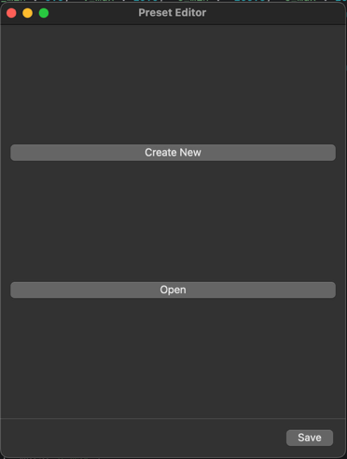
Figure 1 - Preset Editor Launch Page
Within the editor the user will see the sensor thresholds table, event row table, the “Add Event Row” button, the “Edit Event Row” button, the “Delete Event Row” button, and the “Save” button. In the thresholds section, the user will see 3 columns: Channel, Threshold, and Units/Range. Channel will indicate which plug on the DAQ box is associated with the value that is set. The Threshold will be where the user sets the maximum value. The Units/Range will tell the specifications of the sensor associated with that plug, and will tell the user the units the threshold needs to be written in.
In the events section, the rows indicate time, relay number, and analog output. The Time column shows what time the event will take place at relative to when the program is run in the GUI. The relay columns (Ex: Relay 5 NC) show the on/off values of each relay in terms of power, not in terms of whether the valve is open or closed. The analog columns (Ex: A0) show the analog value in terms of percentage.
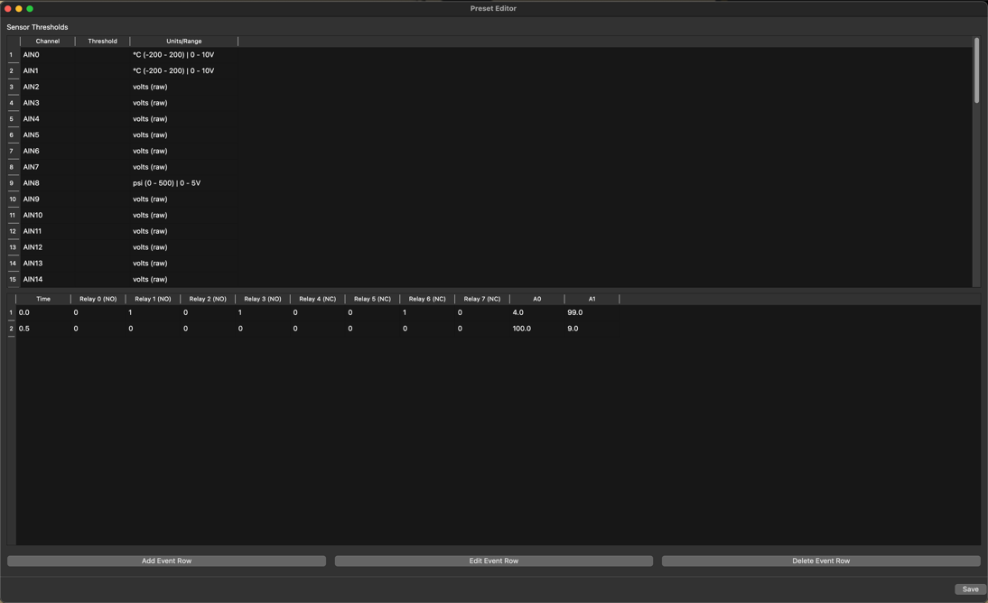
Figure 2 – Preset Editor Main Page

GUI
After opening the GUI, the user can load a preset .json file, start or stop the loaded preset, use the Kill Program button, and control digital outputs using the on-screen switches. It will show the status of a loaded (or not loaded) preset file. The software will display all 56 sensors in mostly line graphs, with some bar graphs. Users will also be able to see the status of both the analog and digital outputs that control the valves.
Each graph will contain whatever sensors are part of a specific grouping of sensors. This grouping is labeled above the graph. Each sensor is colored and tied to their plug number, which is shown on the left of each graph. The bar graphs do not have a labeled grouping nor colored lines, but they are individually labeled and isolated from one another. Unlike the line graphs, the bar graphs show the exact voltage of each sensor they represent.
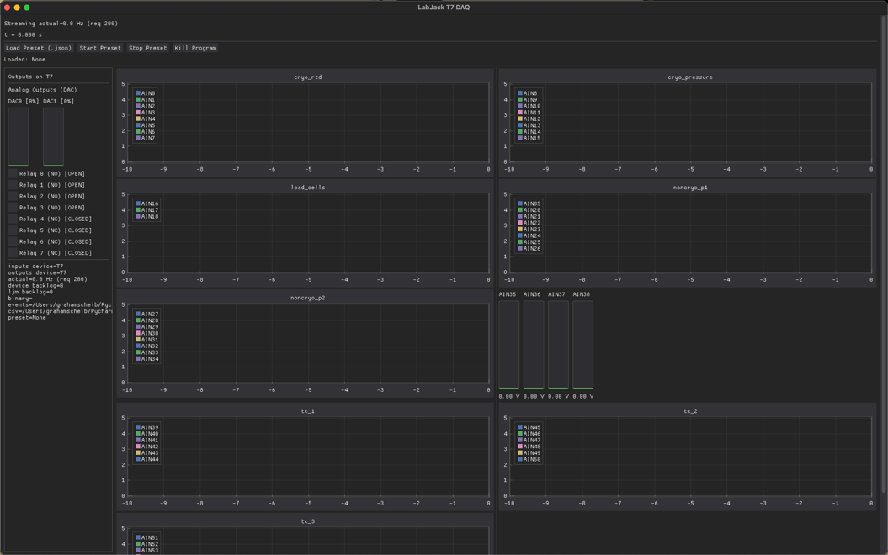
Figure 3 – GUI main page

Exiting the System
To exit the Preset Editor, save the preset file before closing the program. If the file is not saved, changes made since the last save will be lost.
To exit the GUI, use the program’s Kill Program button or close the GUI window. The GUI automatically records data to CSV files while running. In the event of a crash or power loss, data that was already written to the CSV files should remain available, but the most recent buffered data may not be saved. Users should verify that the sensor log file and event log file were created after each test.

Using the System

Preset Editor

Preset File Rules and Validation
- Time is in seconds
- Event times should be entered in sequence
- Thresholds must be numeric
- Threshold units come from the Units/Range column
- Analog outputs are percentages
- Digital outputs are electrical on/off states
- Invalid or missing values may cause the preset to save incorrectly or fail to load

Creating a New Preset file
How to create a new preset file:
- Open Preset Editor application
- Select the button labeled “Create New”
- Choose the file name and save location
- Confirm that the editor screen opens
Be sure to save the file after all edits are done since the application does not save automatically.

Opening an Existing Preset file
How to open an existing preset file:
- Open Preset Editor application
- Select the button labeled “Open”
- Choose an existing .json preset file
- Confirm that the editor screen opens
Be sure to save the file after all edits are done since the application does not save automatically.

Editing Sensor Thresholds
How to edit sensor thresholds:
- Open a file within the Preset Editor software
- Find the channel that is intended to be edited
- Enter the intended maximum value in the correct units
- Click Save
It’s important to note that all thresholds are set in the designated units specified in the Units/Range column.

Adding an Event Row
How to add an event row:
- Open a file within the Preset Editor software.
- Select the button labeled “Add Event Row.”
- Enter the time the event should occur.
- Select the intended digital output states.
- Enter the intended analog output percentages.
- Select “OK.”
- Confirm that the new event row appears in the event table.
- Click Save.
It is important to note that the time value is measured in seconds from when the preset is started in the GUI. Digital outputs are selected as on/off values, while analog outputs are entered as percentages.

Editing an Event Row
How to edit an event row:
- Open a file within the Preset Editor software.
- Select the event row that needs to be edited.
- Select the button labeled “Edit Event Row.”
- Update the time, digital outputs, or analog outputs as needed.
- Select “OK.”
- Confirm that the updated values appear in the event table.
- Click Save.
Be sure to select the correct row before editing. If no row is selected, the software may not open the edit window.

Deleting an Event Row
How to delete an event row:
- Open a file within the Preset Editor software.
- Select the event row that needs to be removed.
- Select the button labeled “Delete Event Row.”
- Confirm that the selected event row has been removed from the event table.
- Click Save.
Be sure to select the correct row before deleting. Once the file is saved, the deleted event row will no longer be included in the preset file.

Saving the File
How to save a preset file:
- Open or create a file within the Preset Editor software.
- Make any needed changes to thresholds or event rows.
- Select the button labeled “Save.”
- Confirm that the file remains in the selected save location.
- Make sure the saved .json file is accessible to the computer running the GUI.
The Preset Editor does not save automatically. Users should save after making changes and before closing the software.

GUI

Starting the GUI
How to start the GUI:
- Confirm that the LabJack T7 is connected to the computer.
- Open the GUI program in PyCharm.
- Run the GUI program.
- Wait for the GUI window to open.
- Confirm that the status area shows that the T7 is connected.
- Confirm that the actual stream rate is not 0.0 Hz.
The GUI should not be opened before the LabJack T7 is connected. If the actual stream rate remains at 0.0 Hz, close the GUI, check the T7 connection, and restart the program.

Running the GUI Without a Preset
How to use the GUI without a preset:
- Connect the LabJack T7 before opening the GUI.
- Open and run the GUI program.
- Do not load a preset file.
- Monitor the live sensor graphs and bar graphs.
- Use the manual output controls if needed.
- Verify that the sensor data and event data files are created.
The GUI can still record sensor data even if no preset file is loaded. In this mode, the user can monitor data and manually control outputs, but no programmed event sequence will run.

Loading a Preset File
How to load a preset file:
- Open the GUI program.
- Select the button labeled “Load Preset (.json).”
- Choose the intended .json preset file.
- Confirm that the loaded preset name appears in the GUI.
- Review the loaded preset before starting it.
Only valid .json preset files should be loaded into the GUI. The selected preset should be reviewed before operation to confirm that the event times, output states, and thresholds are correct.

Starting a Preset
How to start a Preset:
- Open the GUI program.
- Load the intended .json preset file.
- Confirm that the correct preset name is displayed
- Confirm that the LabJack T7 is connected and streaming.
- Select the button labeled “Start Preset.”
- Monitor the GUI as the preset begins running.
Once the preset is started, the GUI will run the programmed events based on the time values in the preset file. The time values are measured from the moment the preset is started.

Stopping a Preset
How to stop a preset:
- Confirm that a preset is currently running.
- Select the button labeled “Stop Preset.”
- Confirm that the preset has stopped.
- Confirm that the outputs have reset as expected.
- Continue monitoring the GUI if needed.
Stopping a preset cancels the remaining scheduled event rows and resets outputs. This does not close the GUI program.

Using Manual Output Controls
How to manually control digital outputs:
- Open the GUI program.
- Locate the digital output checkboxes on the left side of the GUI.
- Select the checkbox for the output that needs to be turned on.
- Clear the checkbox for the output that needs to be turned off.
- Confirm that the displayed relay state changes.
The digital output controls are based on electrical output state, not necessarily valve open or valve closed state. Relays labeled normally open and normally closed may behave differently depending on the valve and relay wiring.

Viewing Analog Output Status
How to view analog output status:
- Open the GUI program.
- Locate the analog output indicators on the left side of the GUI.
- Check the displayed DAC values.
- Confirm that the analog output percentage matches the expected preset or manual output value.
The analog output indicators show the current analog output status. These values are displayed as percentages.

Monitoring Sensor Graphs
How to monitor sensor graphs:
- Open the GUI program.
- Confirm that the LabJack T7 is connected and streaming.
- Locate the sensor graph section in the main GUI window.
- Find the graph group that contains the sensor being monitored.
- Watch the line graph for changes in sensor value over time.
- Use the sensor label or plug number to identify each sensor.
Most sensors are displayed using line graphs. Each graph contains sensors from a specific sensor grouping, and each sensor is labeled by its channel name.

Monitoring Bar Graph Sensors
How to monitor bar graph sensors:
- Open the GUI program.
- Locate the bar graph sensor display.
- Find the sensor channel that needs to be monitored.
- Read the voltage value displayed below or near the bar graph.
- Watch the bar height for changes in live sensor value.
The bar graph sensors are displayed separately from the line graphs. These indicators show the current voltage value for each sensor they represent.

Reviewing GUI Status and Metrics
How to review GUI status and metrics:
- Open the GUI program.
- Locate the status and metrics area.
- Check the T7 connection status.
- Check the actual stream rate.
- Check the requested stream rate.
- Check the device backlog and LJM backlog values.
- Confirm that the correct preset name is shown.
- Confirm that the CSV file paths are listed.
The status and metrics area helps the user confirm that the GUI is connected, streaming, logging, and using the correct preset file.

Reviewing Saved Data Files
How to review saved data files:
- Run the GUI during a test or monitoring session.
- After the test, close the GUI using the intended shutdown method.
- Open the folder where the GUI program files are located.
- Locate the sensor data .csv file.
- Locate the event data .csv file.
- Open the files to confirm that data was recorded.
The GUI automatically creates separate .csv files for sensor data and event data. Users should verify that both files were created after each test.

Ending a GUI Session
How to end a GUI session:
- Confirm that any active preset has been stopped or is safe to stop.
- Select the button labeled “Kill Program” or close the GUI window.
- Confirm that the GUI closes.
- Check the program folder for the sensor data .csv file.
- Check the program folder for the event data .csv file.
Users should verify that the sensor log and event log files were created before considering the session complete.

Troubleshooting & Support

Error Messages

Preset Editor Error Conditions
The Preset Editor does not currently display many custom error messages. Most issues appear as missing data, unchanged screens, or Python/PyCharm errors if a file cannot be opened or saved correctly.
Table 1 - Preset Editor Errors
Message or Condition | Description | Recommended Action
No file opens after selecting Open | The user may have canceled the file selection window, or the selected file may not be a valid preset file. | Select Open again and choose a valid .json preset file created by the Preset Editor.
No new file is created after selecting Create New | The user may have canceled the save window or did not select a file name and location. | Select Create New again and choose a file name and save location.
No change occurs after selecting Edit Event Row | No event row was selected before pressing the edit button. | Select an event row first, then select Edit Event Row.
No change occurs after selecting Delete Event Row | No event row was selected before pressing the delete button. | Select an event row first, then select Delete Event Row.
Threshold value is not saved | The threshold entry may not have been entered as a valid number. Invalid values may be ignored when the preset file is saved. | Enter threshold values using numbers only. Do not include units in the threshold value cell.
Event row is not saved correctly | One or more values in the event row may be missing or invalid. | Review the event row before saving. Use the Add Event Row or Edit Event Row window instead of directly typing into the table when possible.
Changes are lost after closing the Preset Editor | The Preset Editor does not automatically save changes. | Select Save before closing the program. Reopen the .json file to confirm that the changes were saved.
Python or PyCharm error appears when opening a file | The selected file may not be a valid .json file or may not match the expected preset format. | Open a preset file created by the Preset Editor. If needed, create a new preset file and re-enter the preset information.

GUI Error and Status Messages
The GUI displays most error and status messages in the status area at the top of the window. Some messages may also appear in the PyCharm console or in the event log file.
Table 2 - GUI Errors
Error Message | Description | Recommended Action
Status: starting… | The GUI is starting and has not finished connecting to the LabJack T7 or starting the data stream. | Wait for the program to finish starting. If the message does not change, close and restart the GUI.
T7=OK | The LabJack T7 was successfully detected and connected. | No action is needed.
T7=MISSING | The GUI did not detect the LabJack T7. | Check that the T7 is powered and connected to the computer before starting the GUI. Close and restart the GUI after checking the connection.
T7 NOT FOUND: [error] | The program attempted to connect to the LabJack T7 but could not find it. This message may appear in the event log. | Check the USB connection, LabJack drivers, and whether another program is already using the device. Restart the GUI after correcting the issue.
No T7 connected → no data | The GUI cannot collect live sensor data because no T7 connection is available. | Connect the T7 before starting the GUI. Close and reopen the program.
Stream did not start. | The T7 connection may have been attempted, but the data stream did not begin successfully. | Close the GUI, check the T7 connection, and restart the program.
Streaming actual=0.0 Hz | The GUI is not receiving live streaming data. The timer may not begin. | Restart the GUI after confirming that the T7 is connected before the program is opened.
T7 streaming @ [rate] Hz | The T7 data stream started successfully at the displayed rate. | No action is needed.
Stream config warning: [error] | The program encountered a warning while applying stream configuration settings to the T7. | Stop the program, check the T7 connection and channel configuration, then restart the GUI.
Stream error: [error] | An error occurred while reading live sensor data from the T7. | Stop and restart the GUI. Check the USB connection, T7 connection, and LabJack drivers.
STREAM_ERROR [error] | A stream error was recorded in the event log file. | Review the event log to determine when the stream error occurred. Restart the GUI before continuing operation.
STREAM_STOP | The data stream stopped. This may occur during normal shutdown or after a stream error. | If this occurred during normal shutdown, no action is needed. If unexpected, restart the GUI and verify the T7 connection.
DIO init error [channel]: [error] | The GUI could not initialize one of the digital output channels. | Check the T7 connection and output channel configuration. Restart the GUI.
DIO error on [channel]: [error] | A digital output command failed. This may occur during manual control or preset operation. | Stop operation if needed. Check the T7 connection, relay wiring, and assigned output channel.
DAC error on [channel]: [error] | An analog output command failed. | Check the T7 connection and analog output configuration. Restart the GUI if needed.
Config load error: [error] | The selected preset file could not be opened or read. | Confirm that the file exists, is accessible, and is a valid .json preset file.
Invalid config format. | The selected .json file does not match the expected preset format. | Create or edit the preset using the Preset Editor, then load the corrected file into the GUI.
Config parse error: [error] | The preset file opened but could not be interpreted correctly by the GUI. | Check the preset file for missing or incorrectly formatted steps, thresholds, digital outputs, or analog outputs.
File select error: [error] | An error occurred while selecting a preset file from the file dialog. | Try selecting the preset file again. If the issue continues, restart the GUI.
Loaded preset: [filename] | The selected preset file loaded successfully. | No action is needed. Confirm that the correct preset name is shown before starting the preset.
No configuration loaded. | The user selected Start Preset before loading a valid preset file. | Load a valid .json preset file before selecting Start Preset.
Preset running: [preset name] | The loaded preset sequence is active. | Monitor the GUI, sensor readings, and test stand operation.
Preset stopped. Outputs reset to zero. | The preset was stopped, scheduled steps were canceled, and outputs were reset. | Confirm that outputs are in the expected safe state.
CONFIG_STEP | A programmed preset event occurred. This message may appear in the event log. | No action is needed unless the event occurred at an unexpected time. Review the preset file if needed.
CONFIG_STEP (no outputs) | A preset step occurred, but no outputs were changed by that step. | Review the preset file if an output change was expected.
THRESHOLD [channel] [value] > [threshold] | A sensor reading exceeded its configured threshold value. | Treat this as a safety-related event. Review the sensor value, threshold setting, and test conditions before continuing operation.
Logger error: [error] | The GUI could not write to the sensor CSV file or event CSV file. | Check that the program folder is writable, the disk has available space, and the CSV files are not open in another program.
Saved sensor CSV: [file path] | The sensor data CSV file was found when the GUI exited. | No action is needed. Use the file path to locate the sensor data file.
Sensor CSV was not created: [file path] | The expected sensor data CSV file was not found after shutdown. | Check whether the GUI had permission to write files and whether the program closed before logging began.
Saved events CSV: [file path] | The event CSV file was found when the GUI exited. | No action is needed. Use the file path to locate the event log file.
Events CSV was not created: [file path] | The expected event CSV file was not found after shutdown. | Check whether the GUI had permission to write files and whether the program closed before logging began.
Kill switch error: [error] | An error occurred while the GUI was attempting to stop outputs, stop streaming, close the LabJack connection, or exit the program. | Confirm that the test stand is in a safe state. Check the T7 connection and restart the program only after the hardware condition has been verified.

If the GUI does not start correctly, users should close the program, confirm that the LabJack T7 is connected, and restart the GUI. If the actual stream rate remains at 0.0 Hz, the program should be restarted rather than attempting to continue from that state.
If a preset does not load, users should confirm that the selected file is a .json file created by the Preset Editor. Preset files should not be manually edited unless the user understands the required file structure.
If sensor or event CSV files are not created, users should check the program folder, file permissions, available storage space, and whether the program was closed before logging began. After each test, users should verify that both the sensor log file and event log file were created successfully.

Support
For any hardware related issues, please contact LabJack or the appropriate hardware manufacturer for article in question. For software related issues, users can reach out to bjorkpersonal@proton.me for further assistance.

